Eating healthy, daily exercise, meditation and relaxation - all great ideas... in theory! As a working mom I struggle everyday with how to keep my family and myself as healthy as possible. The trouble is, who has the time.
As a physical therapist and yoga instructor by day, people come to me in pain - back pain, neck pain, knee pain, shoulder pain...I evaluate them and through manual therapy techniques I help reduce inflammation, improve range of motion and increase their functional mobility. All of these things help - and dramatically.. But what allows for continued lifelong changes to their physical limitations is the therapeutic exercise and yoga poses that they learn in my office and then do AT HOME on their own. I give my patients manageable, sustainable exercise programs and teach them how to incorporate them into their day. As an expert in my field I spend my day teaching my patients how to make lifestyle changes that will benefit their physical and mental health.... Yet I don’t manage to find the time in my own day.
And so here is my blog – my personal commitment to practice what I preach… To make me and my family as healthy as possible by making small lifestyle changes that will go a long way. Hopefully learn something about myself, my patients and my patience.

Assignment 1 – Take a walk. This is something that I used to do… practically in another life… daily. And it did me a lot of good. But the idea of carving out 45 minutes every day to breathe some fresh air can be daunting – what has to sacrifice so that I can do that… and so nowadays it just doesn’t happen. So this week, I am going to commit to walking every day for a minimum of 10 minutes. And I invite you to join me. This 10 minute walk can be incorporated into your day. It can be an extra lap around your building.. taking the stairs once instead of riding the elevator every time that you have to go to the floor above you… and yes – it can be taking your toddler for a walk – not in a stroller – but an actual walk so that she can show you the fall leaves that have fallen to the ground.

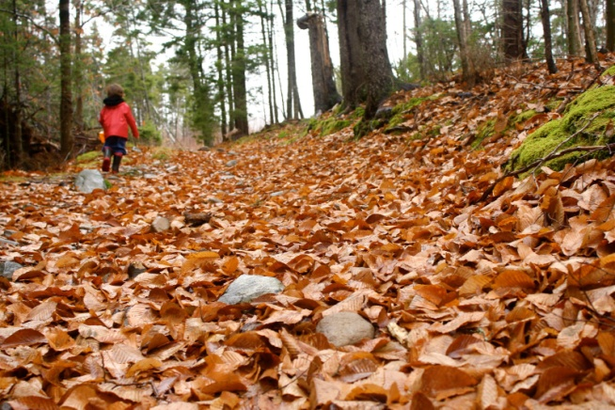

This is not a picture of me or my son – however I hope to have some to post of my walks this week.
Talk to you soon
Dr. G

